**DAILY ONLINE ACTIVITIES SUMMARY**

|  |  |  |  |  |  |  |  |  |
| --- | --- | --- | --- | --- | --- | --- | --- | --- |
| **Date:** | **13-06-2020** | | | | | **Name:** | **Kavya** | |
| **Sem & Sec** | **6th & A** | | | | | **USN:** | **4al17cs041** | |
| **Online Test Summary** | | | | | | | | |
| **Subject** | | **PAP** | | | | | | |
| **Max. Marks** | | **30** | | **Score** | | | **29** | |
| **Certification Course Summary** | | | | | | | | |
| **Course** | **WEB DEVELOPER COURSE HTML CSS JavaScript Learn Web design** | | | | | | | |
| **Certificate Provider** | | | **Udemy** | | **Duration** | | | **6Hours** |
| **Coding Challenges** | | | | | | | | |
| **Problem Statement:1.** Write a C Program to calculate Electricity Bill | | | | | | | | |
| **Status: Yes, I have uploaded all the programs.** | | | | | | | | |
| **Uploaded the report in Github** | | | | | **Yes** | | | |
| **If yes Repository name** | | | | | [**https://github.com/kavya-077/DAILY-STATUS**](https://github.com/kavya-077/DAILY-STATUS) | | | |
| **Uploaded the report in slack** | | | | | **yes** | | | |

Online Test Details: (Attach the snapshot and briefly write the report for the same)

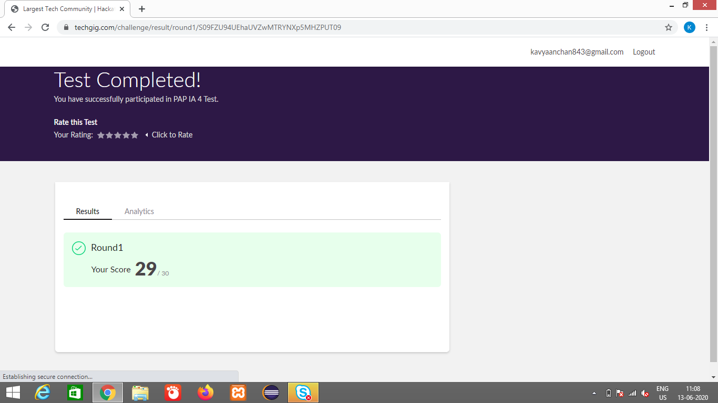

Certification Course Details: (Attach the snapshot and briefly write the report for the same)

**WEB DEVELOPER COURSE HTML CSS JavaScript Learn Web design**

**What we’ll learn**

* create websites
* Apply HTML, CSS and JavaScript
* understand how to create websites
* website design
* create their own websites

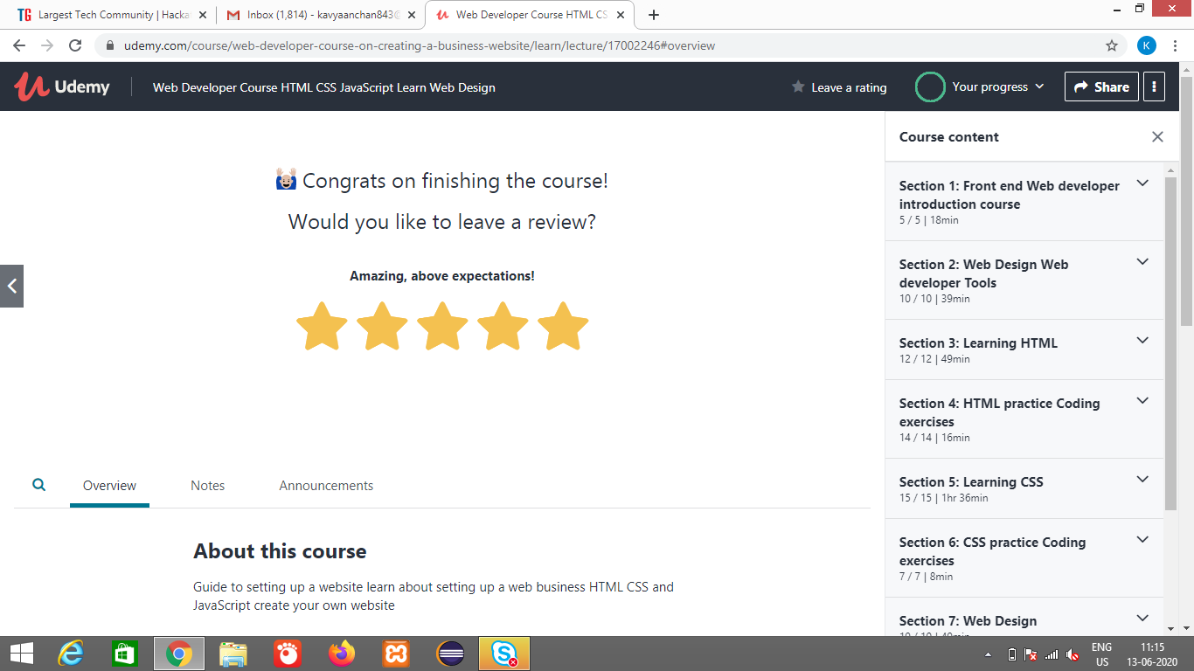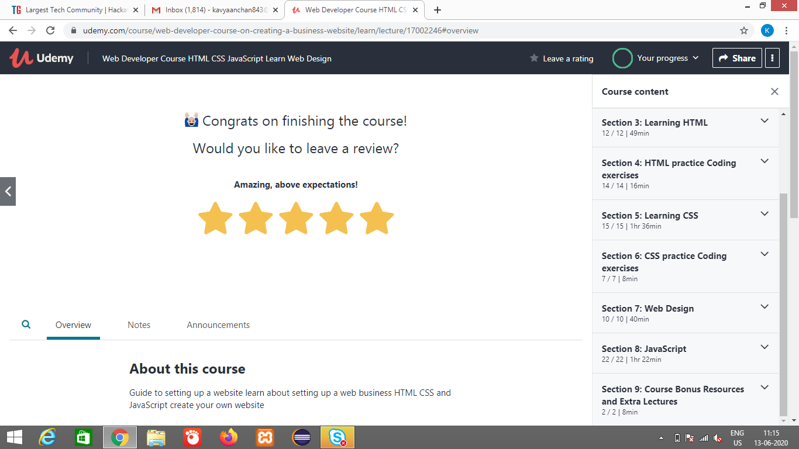

<https://github.com/alvas-education-foundation/kavya-onlinecourse>

Coding Challenges Details: (Attach the snapshot and briefly write the report for the same)

<https://github.com/alvas-education-foundation/kavya-OCA>

<https://github.com/kavya-077/DAILY-STATUS>